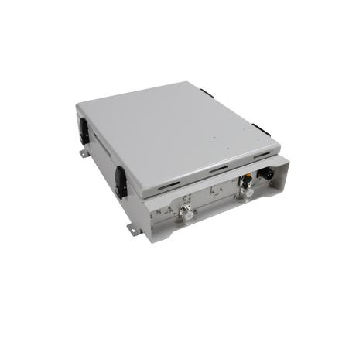
5G-4G Triple Band-adjustable Digital Repeater
Model: DS-DWN3500-30

Product Features
- NSA/SA Support: Compatible with both Non-Standalone and Standalone 5G networks.
- Accurate Synchronization: Built-in 5G base band synchronous detection module (SDM) ensures precise timing with the donor base station.
- Multi-band support offers flexibility to meet various network demands.
- Fine-grained control is achieved through individual sub-band activation/deactivation.
- Intelligent algorithms effectively mitigate uplink interference.
- Independent gain control further optimizes performance.
- Self-control mechanisms minimize interference during new base station deployments.
- NMS facilitates remote/local control and monitoring.

Application Scenario
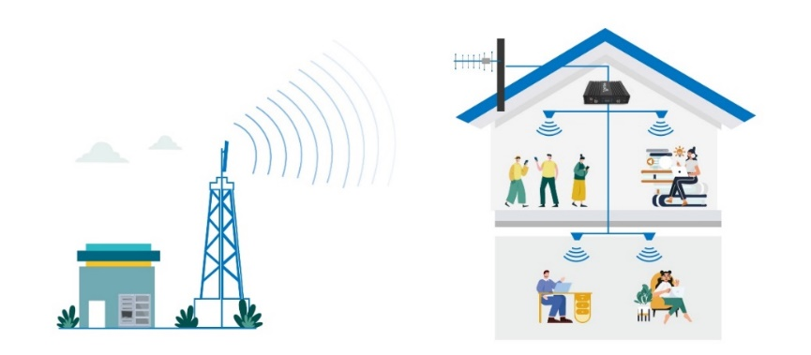

Block Diagram
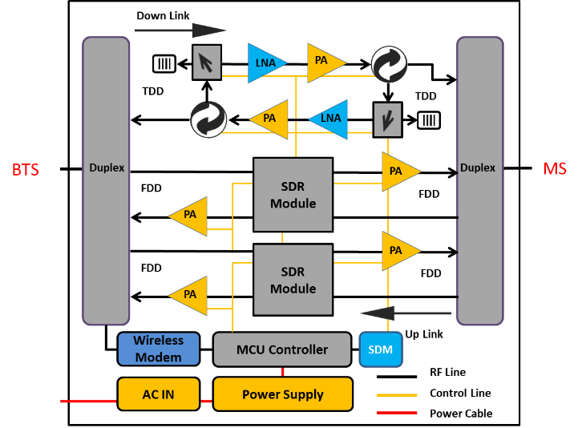

Technical Specifications
P/N: DS-DWN3500-30 |  | B3 (1800) | B1 (2100) | N78 (3500)
Frequency Range | Uplink (adjustable) | 1735.1 – 1754.5 MHz | 1920-1940 MHz | 3600-3700 MHz
Frequency Range | Downlink (adjustable) | 1830.1 – 1849.5 MHz | 2110-2130 MHz | 3600-3700 MHz
Bandwidth (adjustable) |  | 19.4 MHz | 20 MHz | 100 MHz
Number of Sub-bands |  | 1 | 1 | 1
Sub -Band Adjustment Range |  | 0.2-19.4 MHz | 0.2-20 MHz | 5-100 MHz
Max. Gain | Uplink | 75±3 dB | 75±3 dB | 75±3 dB
Max. Gain | Downlink | 80±3 dB | 80±3 dB | 80±3 dB
Automatic Gain / Level Control (ALC) |  | ≥ 50 dB
Gain Flatness (per sub-band) |  | ≤ ±3.5 dB (peak-to-peak)
Max. Input Power Without Damage |  | 0 dBm
Output Power | Uplink | 30±2 dBm | 30±2 dBm | 30±2 dBm
Output Power | Downlink | 30±2 dBm | 30±2 dBm | 30±2 dBm
Out of Band Gain |  | 3GPP compliant
Spurious Emission |  | 3GPP compliant
ACLR |  | 3GPP compliant
EVM |  | ≤ 8% | ≤ 8% | ≤ 3.5%
Frequency Stability |  | ≤ ±0.01 ppm
Noise Figure |  | ≤ 8
VSWR |  | ≤ 2
System Delay |  | ≤ 5 µs
RF Connector |  | N-Female
Impedance |  | 50 Ω
Power Supply | Input | AC 90~264 V, 50/ 60 Hz
Power Supply | Output
Power Consumption |  | ≤ 100 W
Dimensions |  | 430*365*130 mm
Weight |  | ≤ 10 kgs
IP Rating |  | IP55
Operating Temperature |  | -10 °C to 50 °C
NMS | Local | Via RJ45
NMS | Remote | Via Cloud-based NMS (optional)

